Diplomacraft

Vision Document

**Team Royale with Cheese**

Simon Brami

Ryan Cole

J.B. Colette

Eric Do

Marcus Herndon

Ryan Huey

Kenny Nguyen

**1. Introduction** **4**

1.1 Purpose 4

1.2 Scope 4

1.3 Overview 4

**2. Positioning** **4**

2.1 Business opportunity 4

2.2 Problem statement 4

2.3 Product position statement 5

**3. Stakeholder and user descriptions** **6**

3.1 Market Demographics 6

3.2 Stakeholder Summary 6

3.3 User summary 7

3.4 User Environment 7

3.5 Stakeholder Profiles 8

3.6 User Profiles 10

3.7 Key stakeholder or user needs 11

3.8 Alternatives and competition 11

**4. Product Overview** **12**

4.1 Product Perspective 12

4.2 Summary of Capabilities 12

4.3 Assumptions and dependencies 12

4.4 Cost and pricing 13

4.5 Licensing and Installation 13

**5. Product Features** **13**

5.1 System Features 13

5.2 Game Menu Features 13

5.3 Game Features 13

**6. Constraints** **14**

6.1 Usage 14

6.2 Technical 14

**7. Quality Ranges** **14**

**8. Precedence and Priority** **14**

**9. Other Product Requirements** **14**

9.1 Applicable standards 14

9.2 System Requirements 15

9.3 Performance requirements 15

9.4 Environmental requirements 15

**10. Documentation Requirements** **15**

10.1 Release notes, read me file 15

10.2 Online help 15

# 

# 1. Introduction

### 1.1 Purpose

The Purpose of this document is to outline and define the high-level needs and features of the Diplomacraft project. It focuses primarily on the capabilities needed by the target users and stakeholders, providing details on some of the basic user interactions and product features, and their corresponding issues and constraints.

### 1.2 Scope

Our project, Diplomacraft, will feature a desktop application and website that allows users to play the popular board game Diplomacy with other users online. The game will allow up to seven users to play simultaneously. The game will require an active internet connection and a full lobby of human players.

### 1.3 Overview

This document will include our business plan for reaching our target demographics, a rough analysis of our user’s interactions while playing the game, a list of features for our application, and a general overview of our product’s constraints and assumptions.

# 2. Positioning

### 2.1 Business opportunity

In this day and age, people get together and tend to not know what to do once they’re in the same environment. This lack of knowledge leads to antisocial interaction and pushes them towards using their laptops and phones instead of communicating with each other. But with Diplomatron, a group of people’s tendency to migrate towards their electronic devices can bring them closer together than ever.

Software vendors will find that this application will be highly profitable when marketed to the target demographic of young adults through late twenties. Diplomacraft will provide users with the experience of the traditional board game Diplomacy, without actually having to purchase a physical copy. This makes the game portable and easily accessed through any device with Internet connectivity. The product will also be compatible on any device as it utilizes the cross-platform Electron framework.

### 2.2 Problem statement

|  |  |
| --- | --- |
| The problem of | groups of friends and acquaintances feeling lost in social gatherings |
| Affects | people from the ages of young adults to late twenties |
| The impact of which is | a feeling of social awkwardness and possibly losing the bond between one another. |
| A successful solution would be | a simple, yet elegant desktop and web implementation of the classic board game, Diplomacy. This game brings together a group of 2-7 people who can socialize and interact with one another over a common platform. Contrary to current versions available online, our build will be synchronous and have simplified game mechanics that make actions in Diplomacy easier to pick up. |

### 2.3 Product position statement

|  |  |
| --- | --- |
| For | people in the age group of 12-30 |
| Who | struggle with connecting with each other when together. |
| Diplomatron | is a synchronous web and desktop application |
| That | aims to utilize the Electron framework to have it deployed cross-platform for users with any device to connect with each other |
| Unlike | the hardcopy of Diplomacy and current online versions |
| Our product | will be completely mobile and accessible from any web browser. It will have easier to use functions for convoying and will be synchronous which will lead to faster paced games. |

# 3. Stakeholder and user descriptions

### 3.1 Market Demographics

34.3% of the total population owns a computer, which is estimated to be about more than 2 billion people. Of those people, about 700 million of them play games on those devices.

The figures mentioned are significant because it reveals how wide our target audience is. The target for our products are young players who not only love to play strategy board games but psychological games where alliances are constantly built and destroyed. The range in age would be between 12 to 30. The target audience also would be players who own a computer since it is the main platform that this product runs on. The target audience is not limited to just one region since this product will be deployed worldwide. Chances of high profits are likely with audience at this scale.

### 

### 3.2 Stakeholder Summary

|  |  |  |
| --- | --- | --- |
| Name | Description | Responsibilities |
| Project Leader | This stakeholder helps manage all of the developers involved in the project until the product completed and deployed. | Take client’s requirements and works with the team to turn them into user stories, provide guidance to developers involved, checks in with Client. |
| Back end Developers | This stakeholder handles server-side of the project. | Manages the database and server, make changes and updates on the database. |
| Front end Developers | This stakeholder handles the User interface and User experience of the product. | Displays information onto users, designing the interface of the product and implement UI elements. |
| Client (Professor) | This stakeholder requests for a digital version of the game, “Diplomacy.” | Regularly checks in with the project leader for the status of the project, gives requirements for the project or makes changes to those requirements. |

### 3.3 User summary

|  |  |  |  |
| --- | --- | --- | --- |
| Name | Description | Responsibilities | Stakeholder |
| Players | Primary end user of the system | Play diplomacy with other players. | self |

### 

### 3.4 User Environment

1. This product requires users to own a computer to play on.
2. Having Wifi is a must to use this product.
3. It is recommended that players between the ages 12 and 30 use this product for the best user experience
4. This product requires at least 3 players but no more than 7 players.
5. Each user must spend from 5 to 60 mins (they choose) to do their turn.

### 

### 

### 

### 

### 

### 3.5 Stakeholder Profiles

Project Leader

|  |  |
| --- | --- |
| **Description** | This stakeholder helps manage all of the developers involved in the project until the product completed and deployed. |
| **Type** | This person is a guru in software engineering. |
| **Responsibilities** | Take client’s requirements and works with the team to turn them into user stories, provide guidance to developers involved, checks in with Client. |
| **Success Criteria** | The success criteria is defined by being able to have a finished product by the deadline. |
| **Involvement** | Involved in the project as a manager for each developer. |
| **Deliverables** | The product itself. |
| **Comments and issues** | none |

### 

Back end Developers

|  |  |
| --- | --- |
| **Description** | This stakeholder handles server-side of the project. |
| **Type** | This person is a guru in software engineering. |
| **Responsibilities** | Manages the database and server, make changes and updates on the database. |
| **Success Criteria** | Success criteria is defined by how stable and efficient the server is. |
| **Involvement** | Involved in the building and maintenance of the server. |
| **Deliverables** | The server associated with the product. |
| **Comments and issues** | none |

### 

### 

Front end Developers

|  |  |
| --- | --- |
| **Description** | This stakeholder handles the User interface and User experience of the product. |
| **Type** | This person is a guru in software engineering. |
| **Responsibilities** | Displays information onto users, designing the interface of the product and implement UI elements. |
| **Success Criteria** | Success criteria is defined by the completion of the product’s UI. |
| **Involvement** | Involved in creating the UI and UX of the product. |
| **Deliverables** | The product’s UI. |
| **Comments and issues** | none |

### 

Client (Professor)

|  |  |
| --- | --- |
| **Description** | This stakeholder requests for a digital version of the game, “Diplomacy.” |
| **Type** | This person is a guru in software engineering and a business expert. |
| **Responsibilities** | Regularly checks in with the project leader for the status of the project, gives requirements for the project or makes changes to those requirements. |
| **Success Criteria** | The success criteria is defined by how the product is able to meet all of the client’s requirements. |
| **Involvement** | Involved in giving and changing project requirements. |
| **Deliverables** | none |
| **Comments and issues** | none |

### 

### 3.6 User Profiles

Players

|  |  |
| --- | --- |
| **Description** | This is someone who is playing our game. |
| **Type** | This person is a casual user who owns a computer that is interested in playing games. |
| **Responsibilities** | They must win the game by communicating with other players and making in-game orders. |
| **Success Criteria** | The success criteria is defined by the number of users using the product, the continual use of the product by these users, and by having positive ratings. |
| **Involvement** | We will have sample customers to evaluate our system which will guide our vision. |
| **Deliverables** | none |
| **Comments and issues** | none |

### 

### 3.7 Key stakeholder or user needs

|  |  |  |  |  |
| --- | --- | --- | --- | --- |
| Need | Priority | Concerns | Current Solution | Proposed solution |
| Be familiar with Electron | High | The lack of understanding of Electron framework will slow down the project significantly. | Look at Electron tutorials on Lynda | Look at other online tutorials |

### 3.8 Alternatives and competition

* The diplomacy board game itself
  + Strengths
    - Does not require a computer
    - Can be easily portable
  + Weakness
    - Lack of automation in some tedious parts of the game compared to its virtual counterpart, such as the thought process of determining if a order is valid versus a computer doing the determining for them .
* Backstabber and other online diplomacy games
  + Strengths
    - Easy portability
  + Weakness
    - UI is slightly complex for casual players to get a grasp on

# 4. Product Overview

### 4.1 Product Perspective

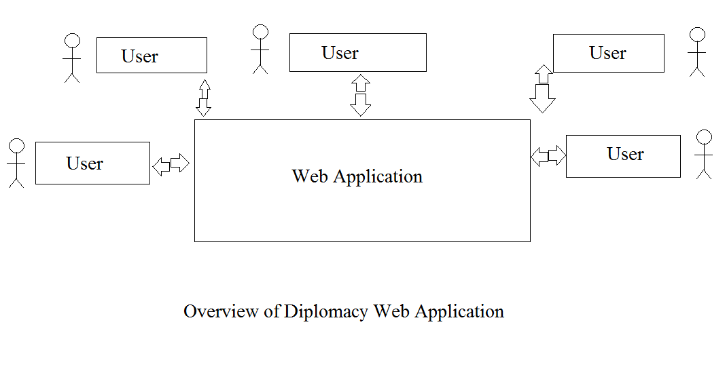

### 4.2 Summary of Capabilities

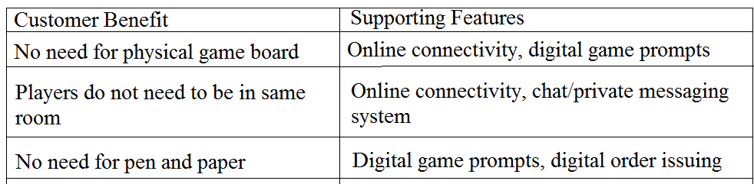

### 4.3 Assumptions and dependencies

1. It will be assumed that players have a basic understanding of the English language.

2. It will be assumed that players have access to an Internet-capable device.

3. It will be assumed that players understand the rules of *Diplomacy*.

4. It will be assumed that players understand the concept of a private messaging system.

### 4.4 Cost and pricing

Our online version of the board game *Diplomacy* will be provided to players free of charge. There should be no cost to us, other than time spent to create the game.

### 4.5 Licensing and Installation

As players will create an account to play our online version of the board game *Diplomacy*, usernames and passwords will have to be secured. A desktop version of the board game will be provided to players, and as such, will need installation permissions on to the player’s computer.

# 5. Product Features

### 5.1 System Features

1. Start Application
2. Exit Application

### 5.2 Game Menu Features

1. Register
2. Sign In
3. List my Lobbies
4. Join a lobby
5. Create a lobby

### 5.3 Game Features

1. Create Game
2. Edit Game
3. Exit Game

### 

# 6. Constraints

### 6.1 Usage

The Game must be playable on different computers.

Rules of the game must be accessible for the user and understandable.

### 6.2 Technical

The product must be separated in two parts:

* Backend API (running on .NET Core)
* Front End client (using Electron framework)

Must use relational database (SQL Server Db)

The game must be fun to play, so the user experience must be understandable for everyone.

# 7. Quality Ranges

The quality range of Diplomacraft will be of medium condition. Since Diplomatron is only an implementation of a board game, the quality of features does not have to be top notch. A lack of it will not severely impact anyone or anything that utilizes it.

# 8. Precedence and Priority

|  |  |
| --- | --- |
| **Priority** | **Feature (By Numbers in Heading 5)** |
| High | 5.1 |
| Medium | 5.2 |
| Low | 5.3 |

# 9. Other Product Requirements

### 9.1 Applicable standards

The Diplomacraft game must respect all original rules from the Diplomacy board game.

### 9.2 System Requirements

As the game is developed with cross-platform technologies, the game must be executed on a Windows, Linux or MacOs machine.

### 9.3 Performance requirements

None

### 9.4 Environmental requirements

None

# 10. Documentation Requirements

### 10.1 Release notes, read me file

The Read Me file and release notes can be found in our github repository.

### 10.2 Online help

Can be found in the Read Me file in our github repository.

## 